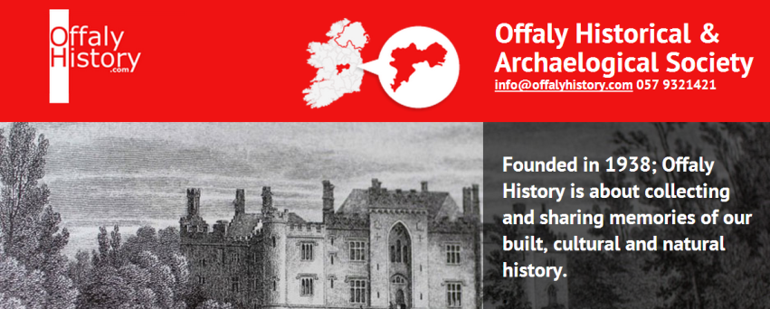

RARE & OLD PUBLICATIONS
FOR SALE

Tullamore, Ireland

info@offalyhistory.com

2016

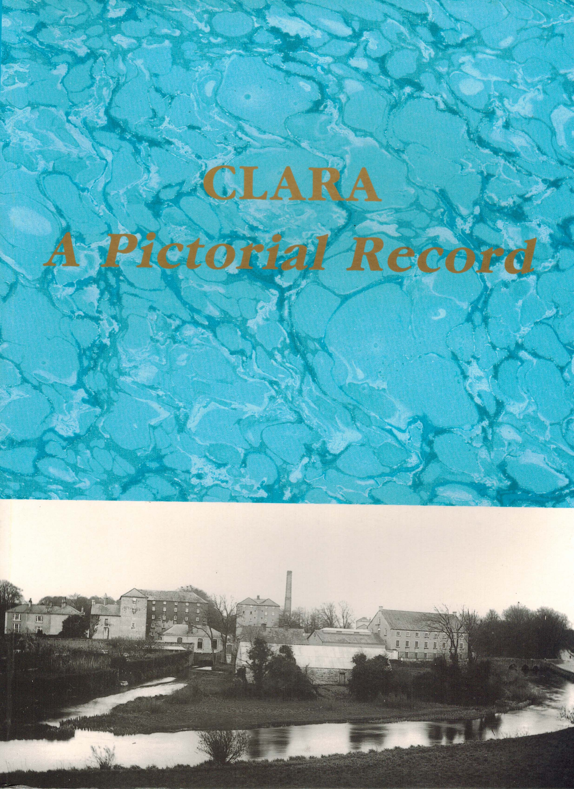 | Clara A Pictorial Record  (Offaly,2006), 195 pp, SB, €25, HB €50  Offaly Historical and Archaeological Society SCARCE  Clara, in the heart of County Offaly, was the only town to see economic growth in the nineteenth century. This strong industrial tradition built on the basis of a successful linen industry in the eighteenth century, saw continued expansion under the entrepreneurship of the Goodbody family in the nineteenth century and up to the 1960’s. This book sets out to catalogue that record of growth in town life from the 1870’s to the present day. Some 300 photographs are reproduced here in the form of a town album that will be treasured by the people of Clara and all who love their native place and its people.
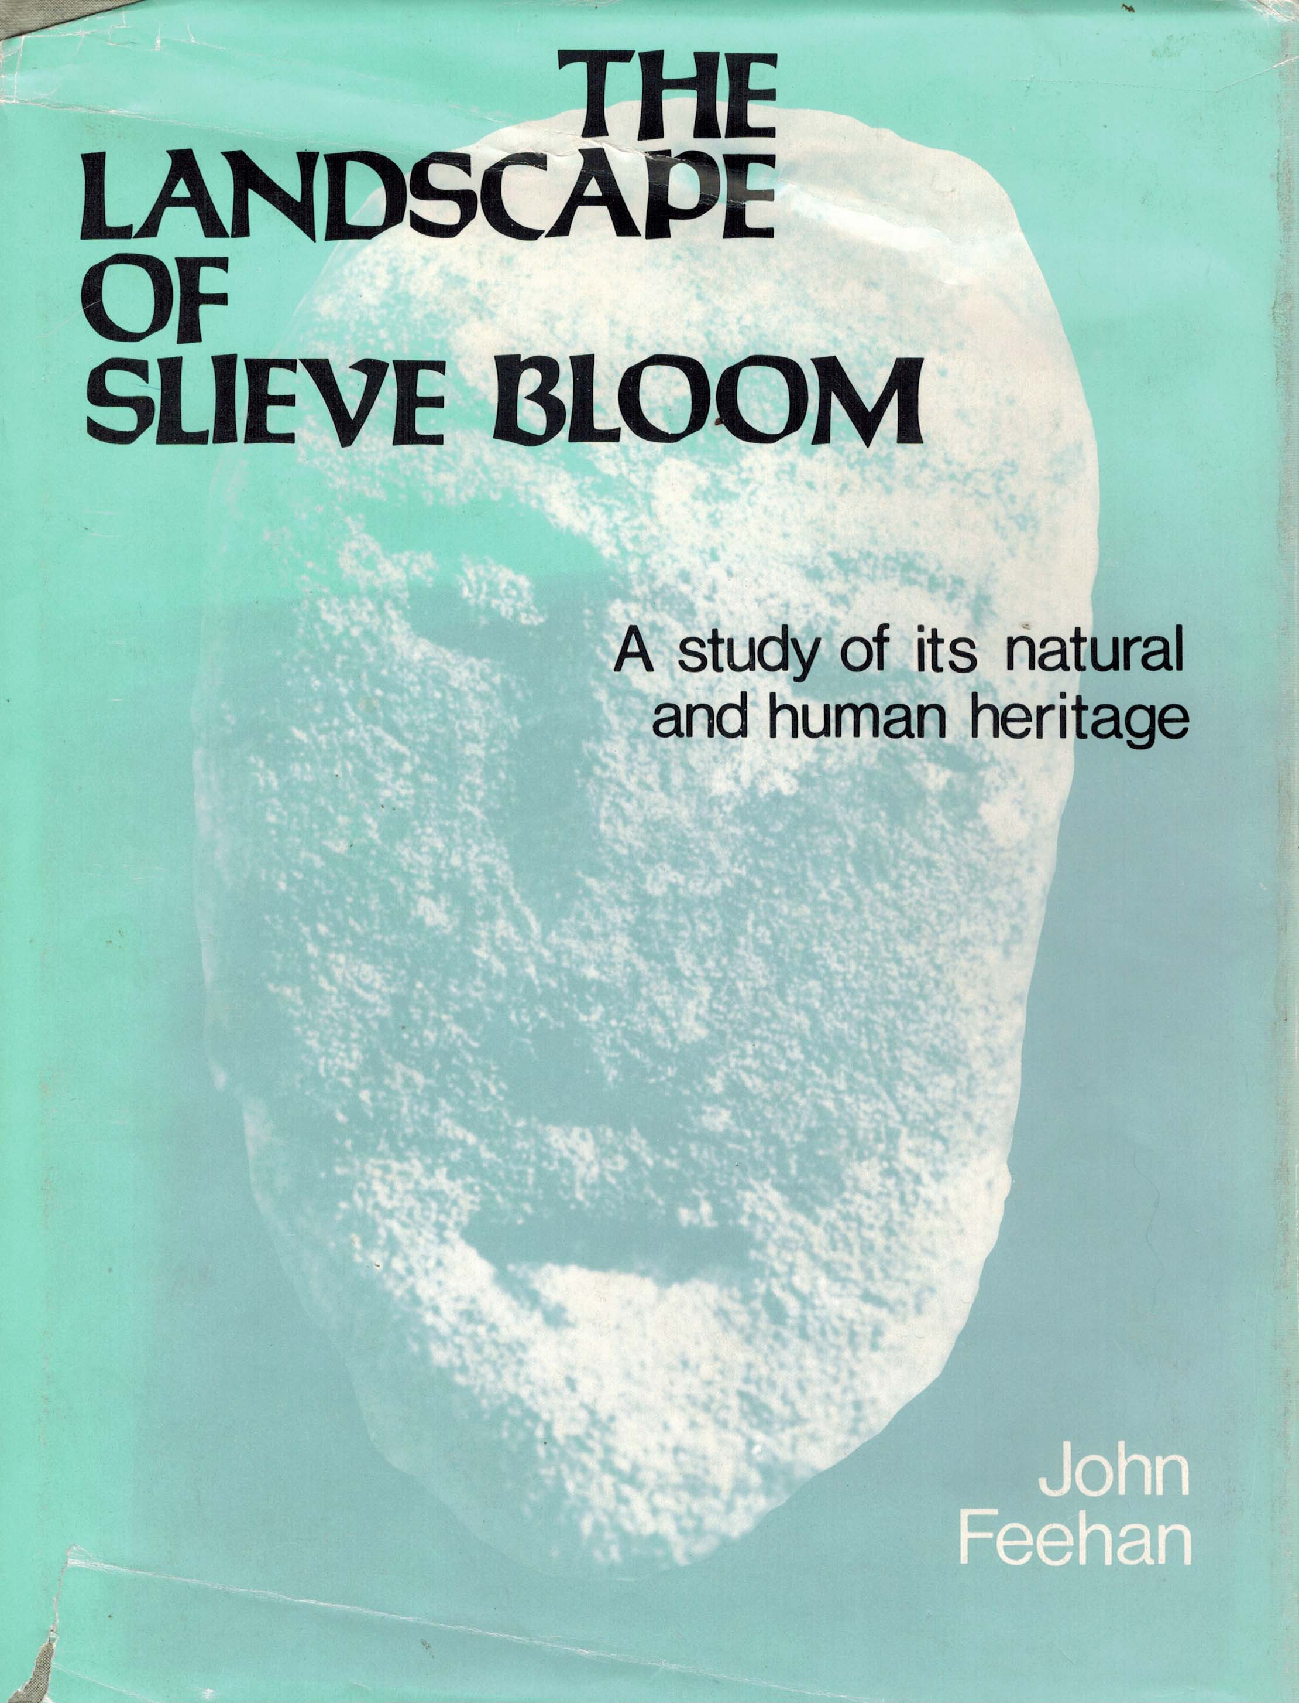  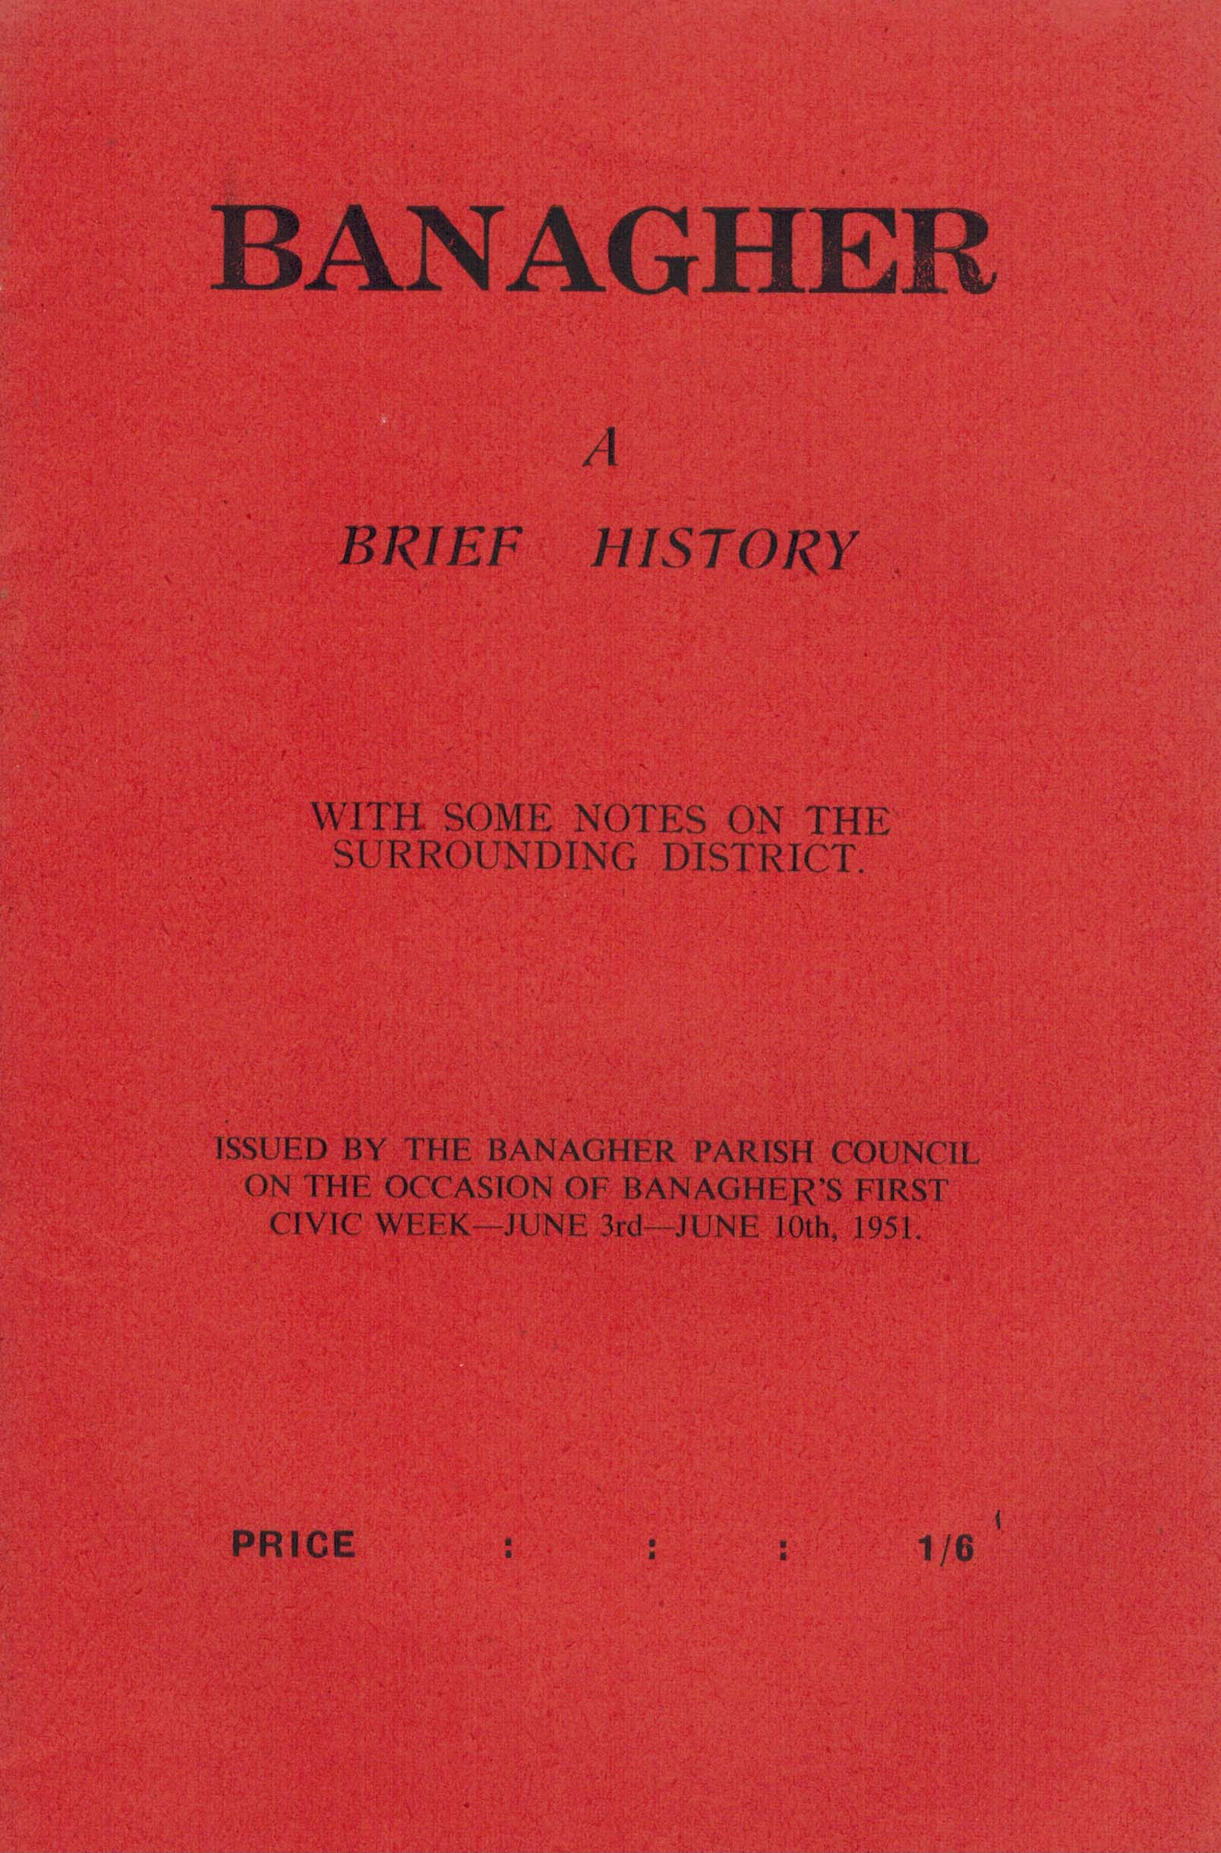 | The Landscape of the Slieve Bloom – A study of its natural and human heritage (Dublin 1979), 285pp HB, €75  John Feehan (Slight damage to cover)  This is a unique study of the natural and human history of one of the most fascinating areas in central Ireland. It is the first detailed study of the Slieve Bloom, and ranks in its concern for the total environment, from the rocks that constitute its heart to the history of the human communities who have moulded the face of the varied landscapes, alongside Estyn Evans’ enchanting study of the Mourne Mountains. It is unique also in the extent to which it is based on the author’s original research, for surprisingly little has been written about this region.  Banagher A Brief History (Banagher 1951), 28 pp, SB, €25  Banagher Parish Council SCARCE  Banagher – A Brief History is a book issued by the Banagher Parish Council on the occasion of Banagher’s first civic week – June 3rd and June 10th, 1951. In the articles and contributions, the history of an ancient town is briefly told. Set beside the lordly Shannon, its story goes back for many generations even to remote times before the days of St. Reynagh, the sister of the great St Finan of Clonard, who founded here a nunnery, and with those sainted name the fortunes of our ancient town have ever since been intertwined.
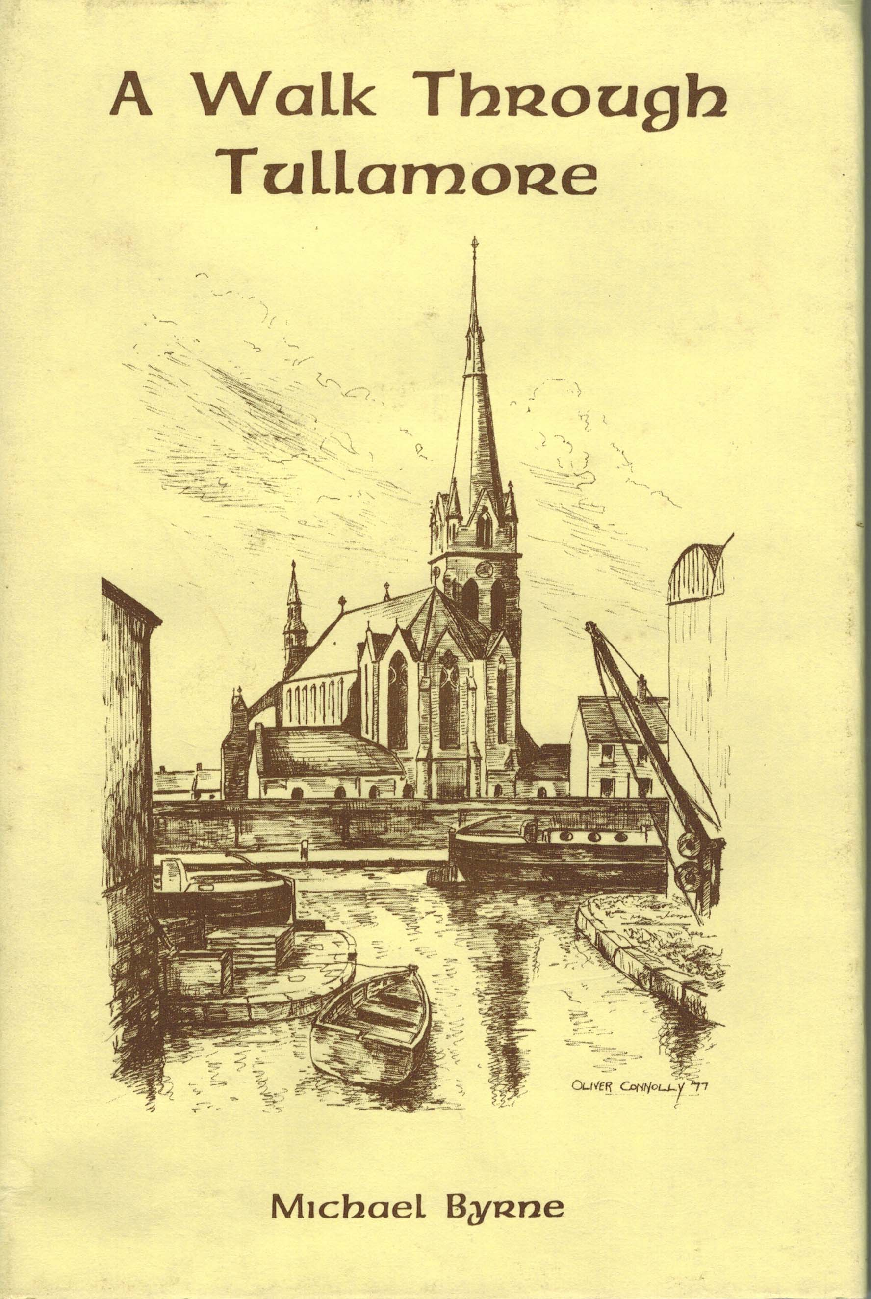 | A Walk Through Tullamore (Tullamore 1980), 66 pp, HB, €25  Michael Byrne SCARCE  This study is mainly concerned with the physical development of Tullamore between 1700 and 1900. Michael Byrne has written the book in the form of a walking tour so as to encourage readers to look at the remains of several centuries of development. Visitor and native are invited to observe an evolving landscape in a middle sized Irish town. The tour is a long one and it is recommended that it be taken in two stages or even broken up further as suits.
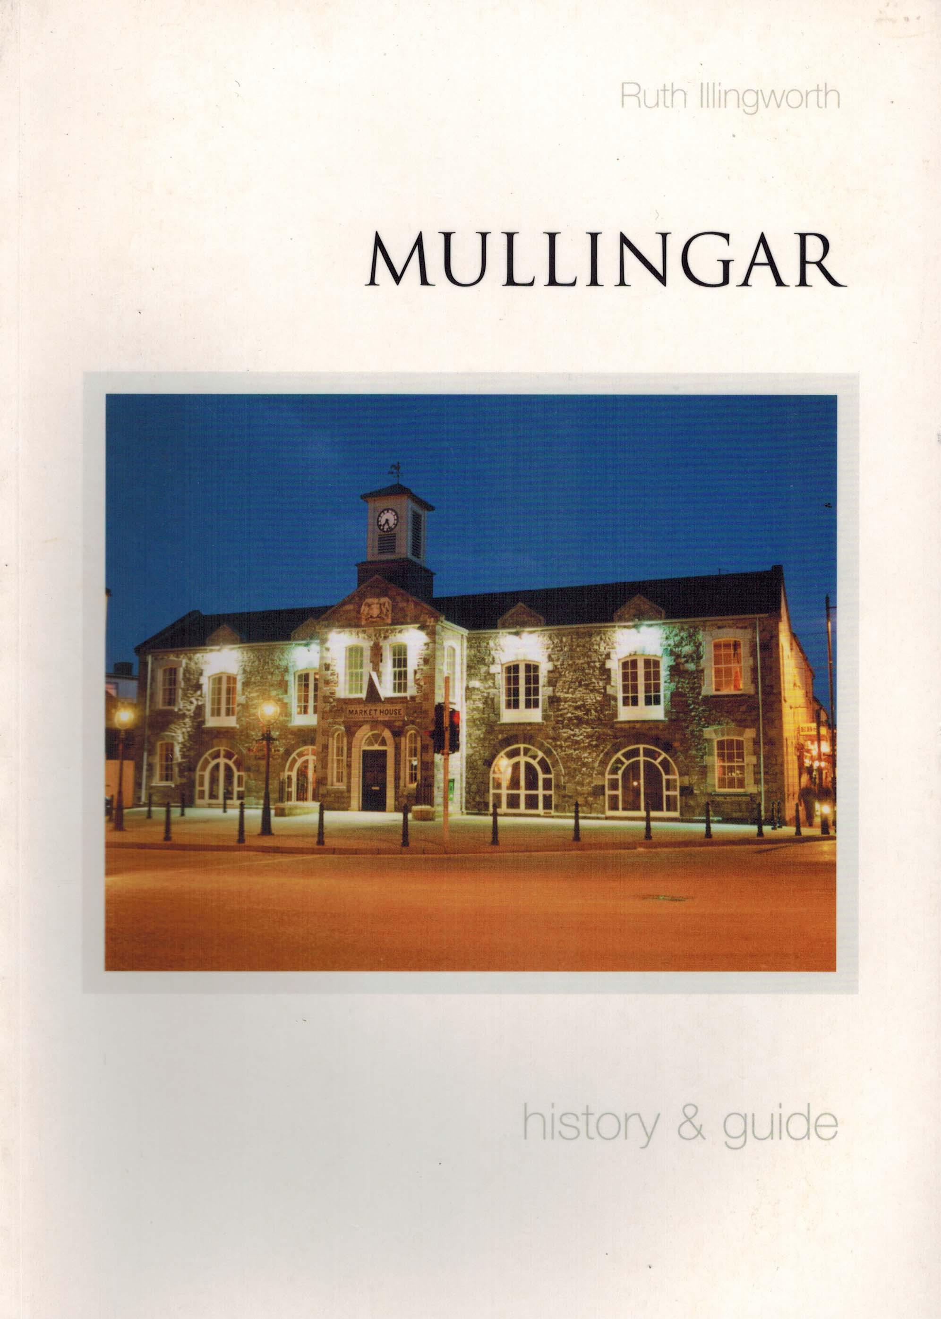 | Mullingar History & Guide (Dublin, 2007), 157 pp, SB, €15  Ruth Illingworth  Known in Irish as An Muilleann Cearr, Mullingar is probably the only town in Ireland to be named after a miracle. The illustrated book tells the story of the town’s rich historical and archaeological heritage form the earliest times to the present day. It also contains a guided tour of the town’s historic streets and buildings. The book will give residents and visitors a broad picture of one of Ireland’s oldest towns.  Ruth Illingworth, the author of this work, grew up in Mullingar and still lives in the town. She is a lecturer and has taught at NUI Maynooth, and is President of the Westmeath Archaeological and Historical Society. She writes articles on local history for the Westmeath Examiner, broadcasts on Midlands Radio 3 and is also a tour guide. She is also a member of Mullingar Town Council.
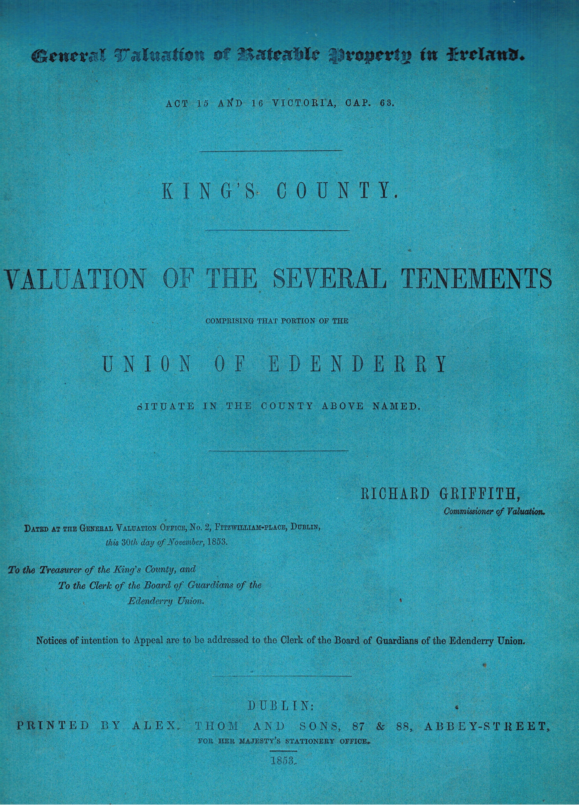 | General Valuation of Rateable Property of Ireland, Kings County, Valuation of the Several Tenements, Union of Edenderry (Dublin, 1853) 80 pp, SB, €75  Richard Griffith Commissioner of Valuation  A very rare book which was printed in Dublin by Alex. Thom and Sons, 87 & 88 Abbey Street, for her majesty’s stationery office in 1853. It is a valuation of the several tenements comprising that portion of the Union of Edenderry situate in the county above named. The status accorded by Irish record searchers to the information found in Sir Richard Griffith's General Valuation is in large part due to the destruction of the nineteenth century population schedules. His General Valuation, conducted under the Act of 15 & 16 Victoria, c 63 between 1853 and 1865, constitutes an almost complete enumeration of land occupiers for the years following the Great Famine.
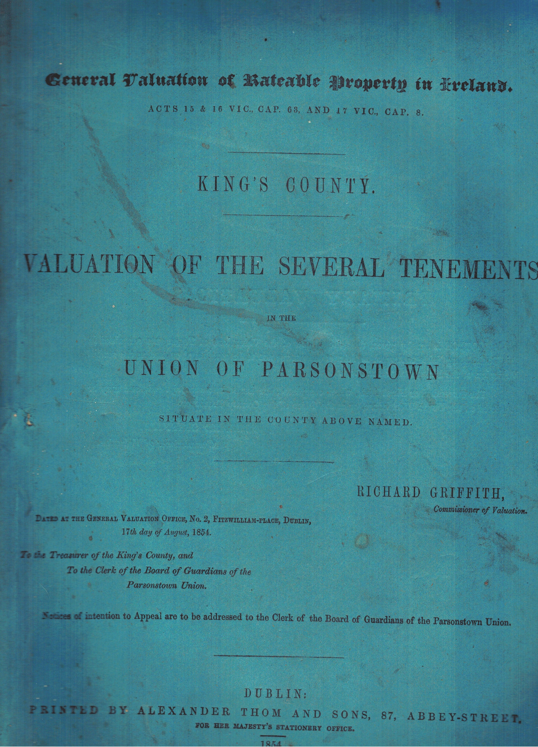 | General Valuation of Rateable Property of Ireland, Kings County, Valuation of the Several Tenements, Union of Parsontown (Dublin, 1853) 222 pp, SB, €150  Richard Griffith Commissioner of Valuation  A very rare book which was printed in Dublin by Alex. Thom and Sons, 87 & 88 Abbey Street, for her majesty’s stationery office in 1854. It is a valuation of the several tenements comprising that portion of the Union of Parsonstown situate in the county above named. The status accorded by Irish record searchers to the information found in Sir Richard Griffith's General Valuation is in large part due to the destruction of the nineteenth century population schedules. His General Valuation, conducted under the Act of 15 & 16 Victoria, c 63 between 1853 and 1865, constitutes an almost complete enumeration of land occupiers for the years following the Great Famine.
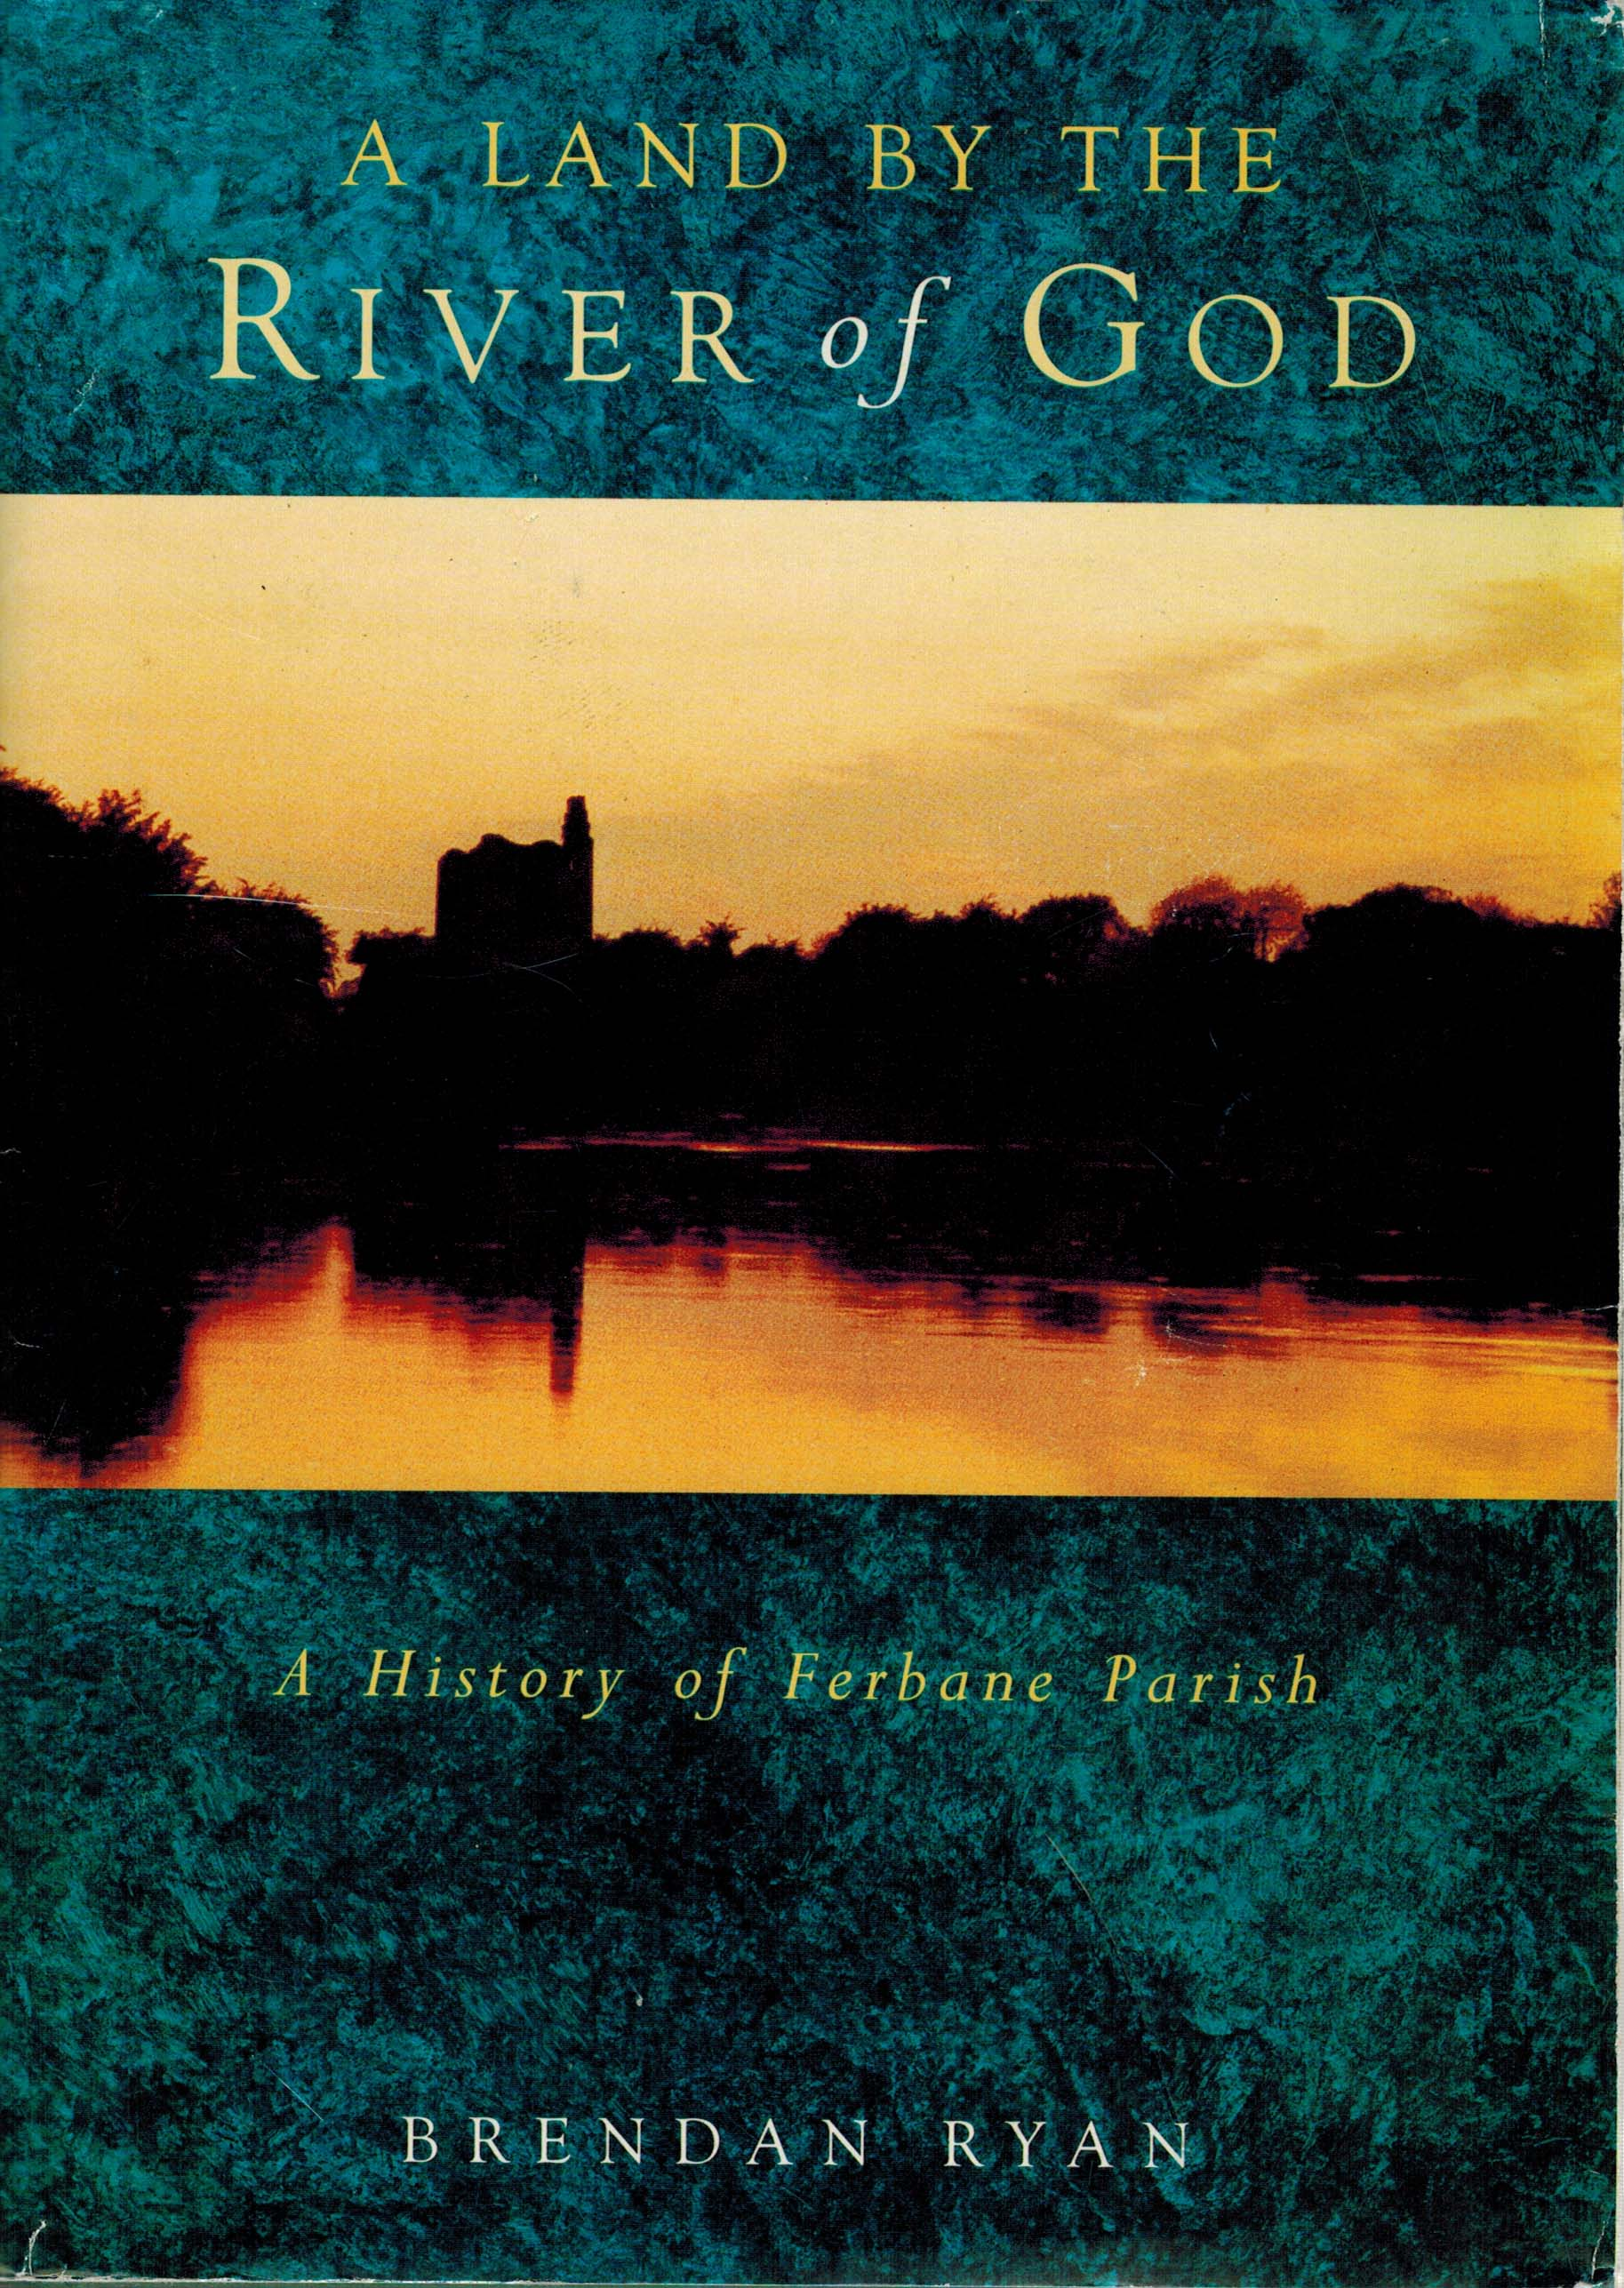 | A Land By the River of God – A History of Ferbane Parish (Ferbane, 1994), 348 pp, HB, €50 SCARCE  Brendan Ryan  This is the first comprehensive compilation of the history of Ferbane Parish, or Wheery and Tisaran, as it is also known. The rise to power of the great Mac Coglan sept is chronicle, together with in-depth  15 tours of Laois’s built heritage, starting in the north-west of the county and concluding in the south east by Carlow: each should take about a day, allowing for strolling and breaks: and parts of each may be cobbled together depending on interests.
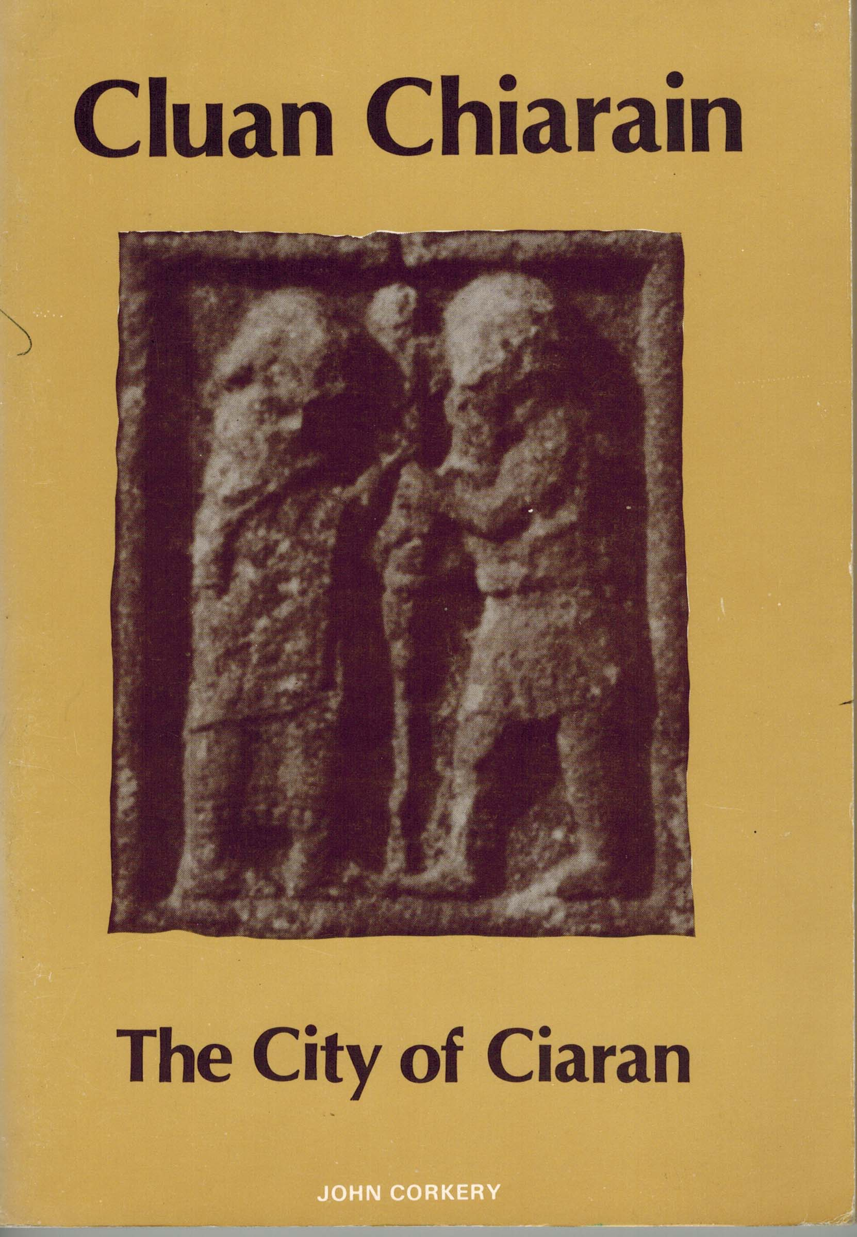 | Cluan Chiarain – The City of Ciaran  (Longford 1979), 80 pp, SB, €15 SCARCE  Wonderful guide to the ancient monastic city of Clonmacnoise.  Canon Corkery’s text will be found by visitors and pilgrims alike, to be both an informed guide to the site and an inspiring introduction to the experience. It combines the learning of the historian and the antiquarian with the feel for words of the poet and the pilgrim’s sense of the holy. It will help to make any visitor into a pilgrim and will give the pilgrims new insights into this “still centre” at the heart of Ireland, where man’s heart can open up to God and find “peace which surpasses all understanding”.
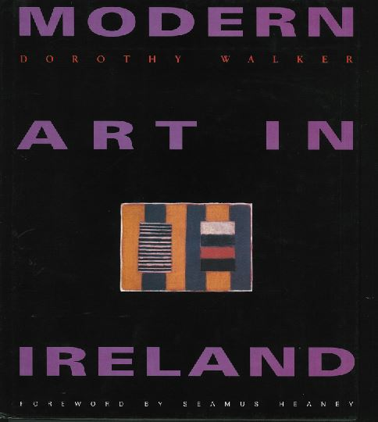 | Modern Art In Ireland (Dublin, 1997), 239 pp, HB, €100.  Dorothy Walker  During World War II Irish artists who had been living and working on the Continent and in Britain came home to neutral Ireland and began to react against the Royal Hibernian Academy and Nationalist Realism. This survey begins here and goes on to trace a half-century of political and cultural development – from the Irish Exhibition of Living Art through the creation of the Arts Council, the Rosc exhibitions and the advent of the Irish Museum of Modern Art, while looking at the artists themselves. The author focuses on the visual arts in Ireland, but she does not neglect the emigres: refusing to establish criteria for "Irishness", she chooses to talk about the art itself, identifying a distinct Celtic element in Sean Scully's abstract paintings and suggesting possible origins of Francis Bacon's artistic sensibility in his childhood on the Curragh of Kildare. She also gives an account of the works and influence in Ireland of artists who are not Irish, such as Joseph Beuys, who came to Ireland after being sacked from his teaching post in Germany, and the array of modernists and postmodernists whose works appeared in the early Rosc exhibition.
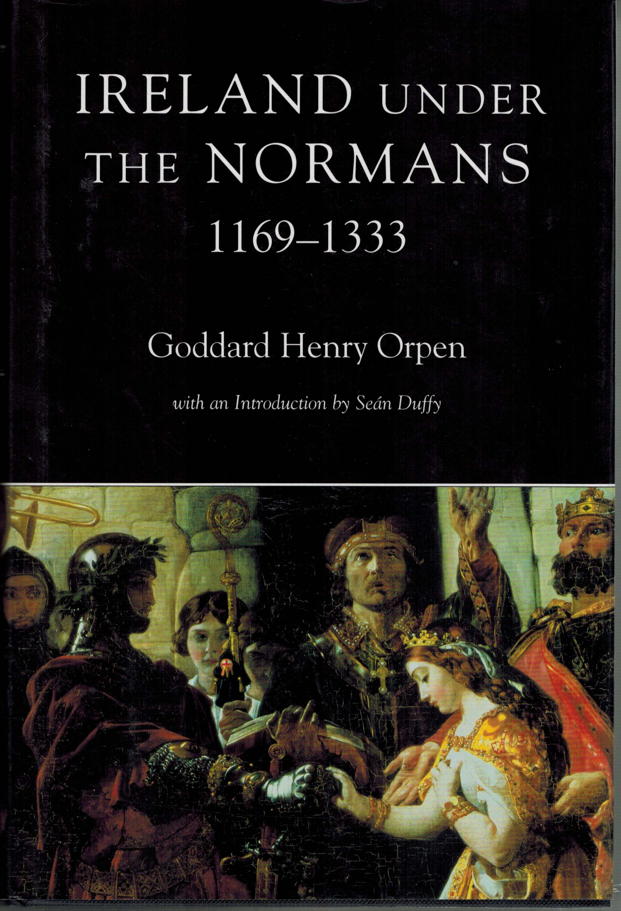 | Ireland under the Normans 1169-1333 (Dublin, 2005), 633 pp, HB, €80.  Goddard Henry Orpen  Orpen's magnum opus was originally published in two volumes in 1911, and a further two in 1920 - a total of some 1500 pages. Clarendon Press subsequently reissued the four volumes in 1968. It remains unsurpassed to this day. This Four Courts Press edition, which is printed in one volume, incorporates the original pagination so that readers can refer to the earlier edition with ease. The book itself deals with events in Ireland from the Cambro-Norman invasion of 1169 to the portentous murder of the earl of Ulster in 1333 as the history of a number of regions, rather than focusing exclusively on the concerns of the English king's administration, but his example has never hitherto been followed in relation to the Anglo-Irish colony. Although the project had its detractors (most notably Eoin MacNeill, who held the Chair of medieval history in UCD in 1909), it remains the definitive work on the period.
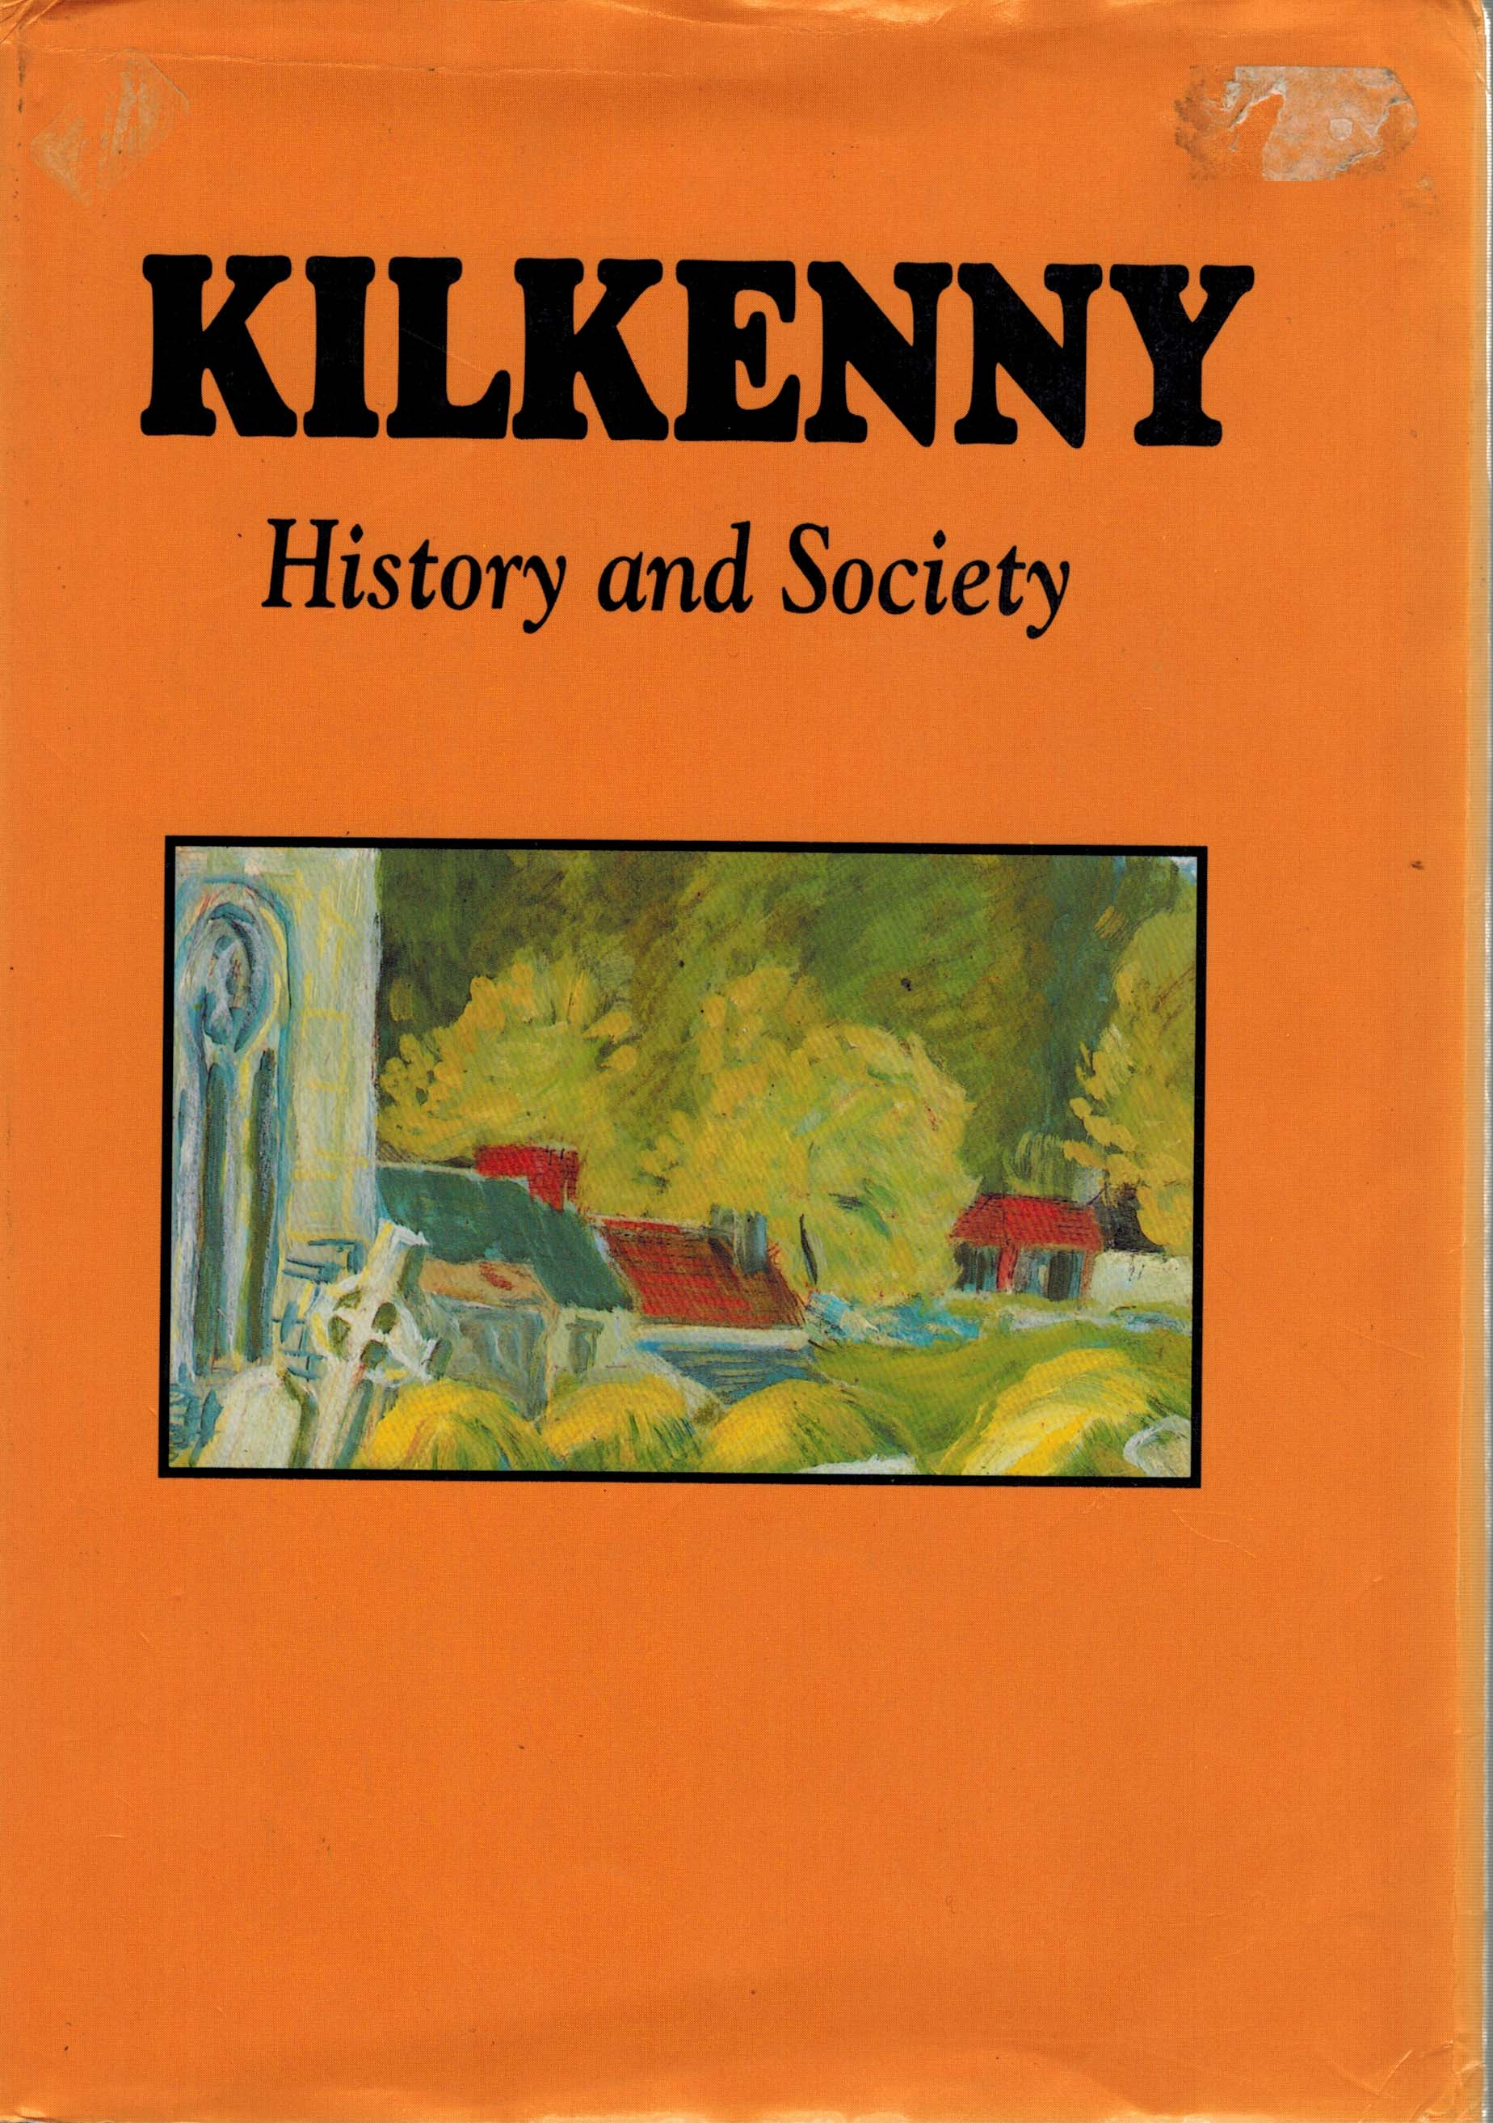 | Kilkenny History & Society (Dublin, 1990), 715 pp, HB, €45.  Editors – William Nolan & Kevin Whelan  This is the third volume in the Irish County History Series. This is the most extensive multi-disciplinary study ever undertaken on Kilkenny. Archaeologists, medievalists, Celtic scholars, geographers, placename scholars and historians of economics, culture and politics combine to provide an fascinating account of this key region.
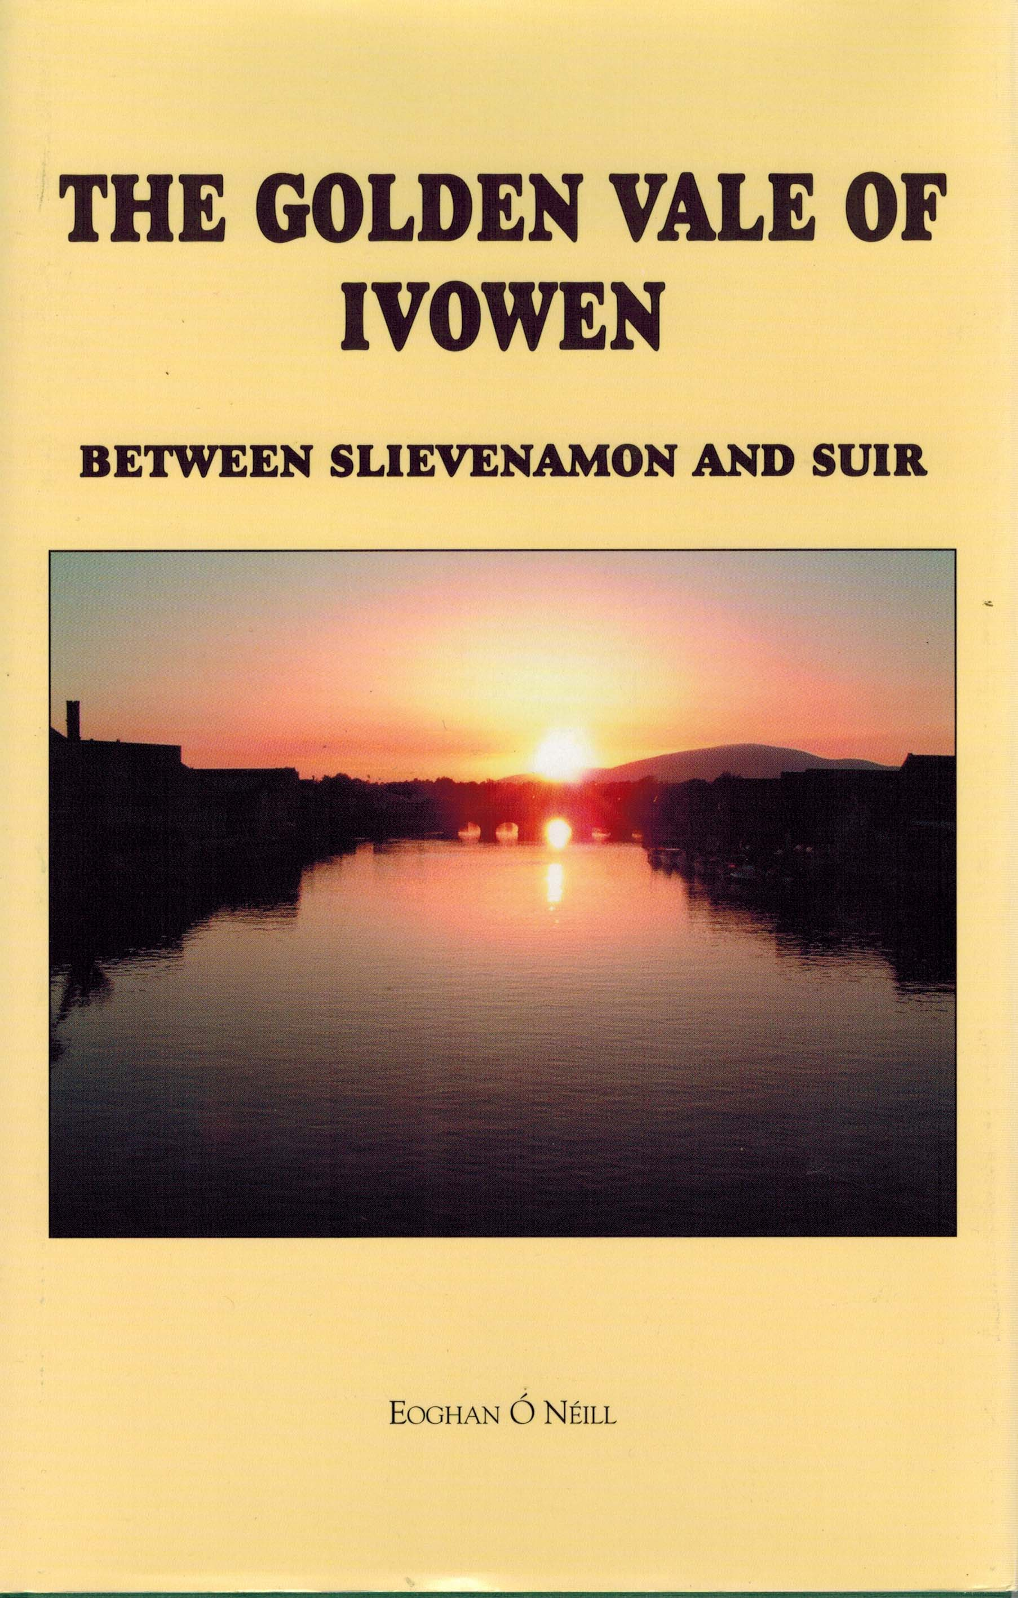 | The Golden Vale of Ivomen – Between Slievenamon and Suir (Dublin, 2001), 604 pp, HB, €25.  Eoghan O’ Neill  The subject of this work is the story of the origins, development and culture of the people, and particularly farming, in a rural district in South Tipperary on the borders of south east Kilkenny and Waterford in the valley of the River Suir. This district, long famed for its richness and natural beauty, has been known for hundreds of years as the Golden Vale. The story covers some seven hundred years from the 12th century, and particularly from the late Middle ages to the beginning of the 20th century. It touches on the social, political, military, literary and cultural history of the community, and is largely based upon the traditions and written records, documents and correspondence of various families in the area, their relations and neighbours. This account, however, is not just purely local history. It does indeed throw light on the real hidden Ireland as it exited here, so very different from that portrayed elsewhere.
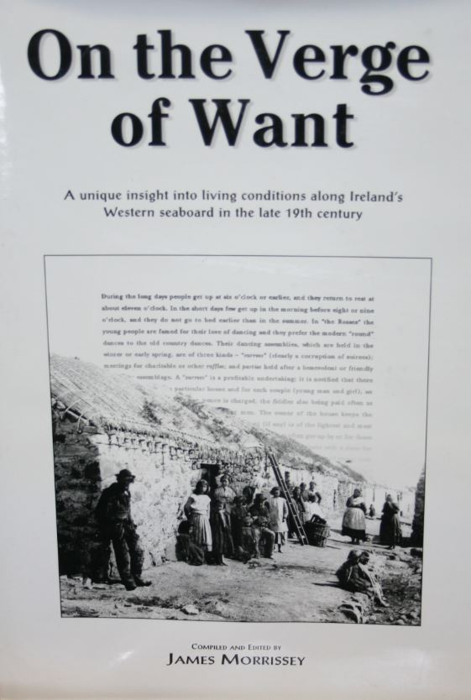 | On the Verge of Want (Dublin, 2001) 247 pp, HB, €32.  Compiled & Edited By - James Morrisey  A unique insight into the living conditions along Ireland’s Western seaboard in the late 19th century. In the early 1890s, a team of inspectors traversed the West of Ireland to undertake a confidential study of the living conditions of the people on behalf of the recently established Congested Districts Board.  It vividly captures the plight of the people — as outlined in the ‘base line reports’ of these inspectors — in the towns and townlands of counties Donegal, Sligo, Leitrim, Roscommon, Mayo, Galway, Kerry and Cork. The inspectors recommended that change could only be rooted in ‘helping people to help themselves’.  Progress could only be achieved by training menfolk in improved methods of land cultivation, and in coastal areas, fishing, and by assisting women in better standards of home-keeping.
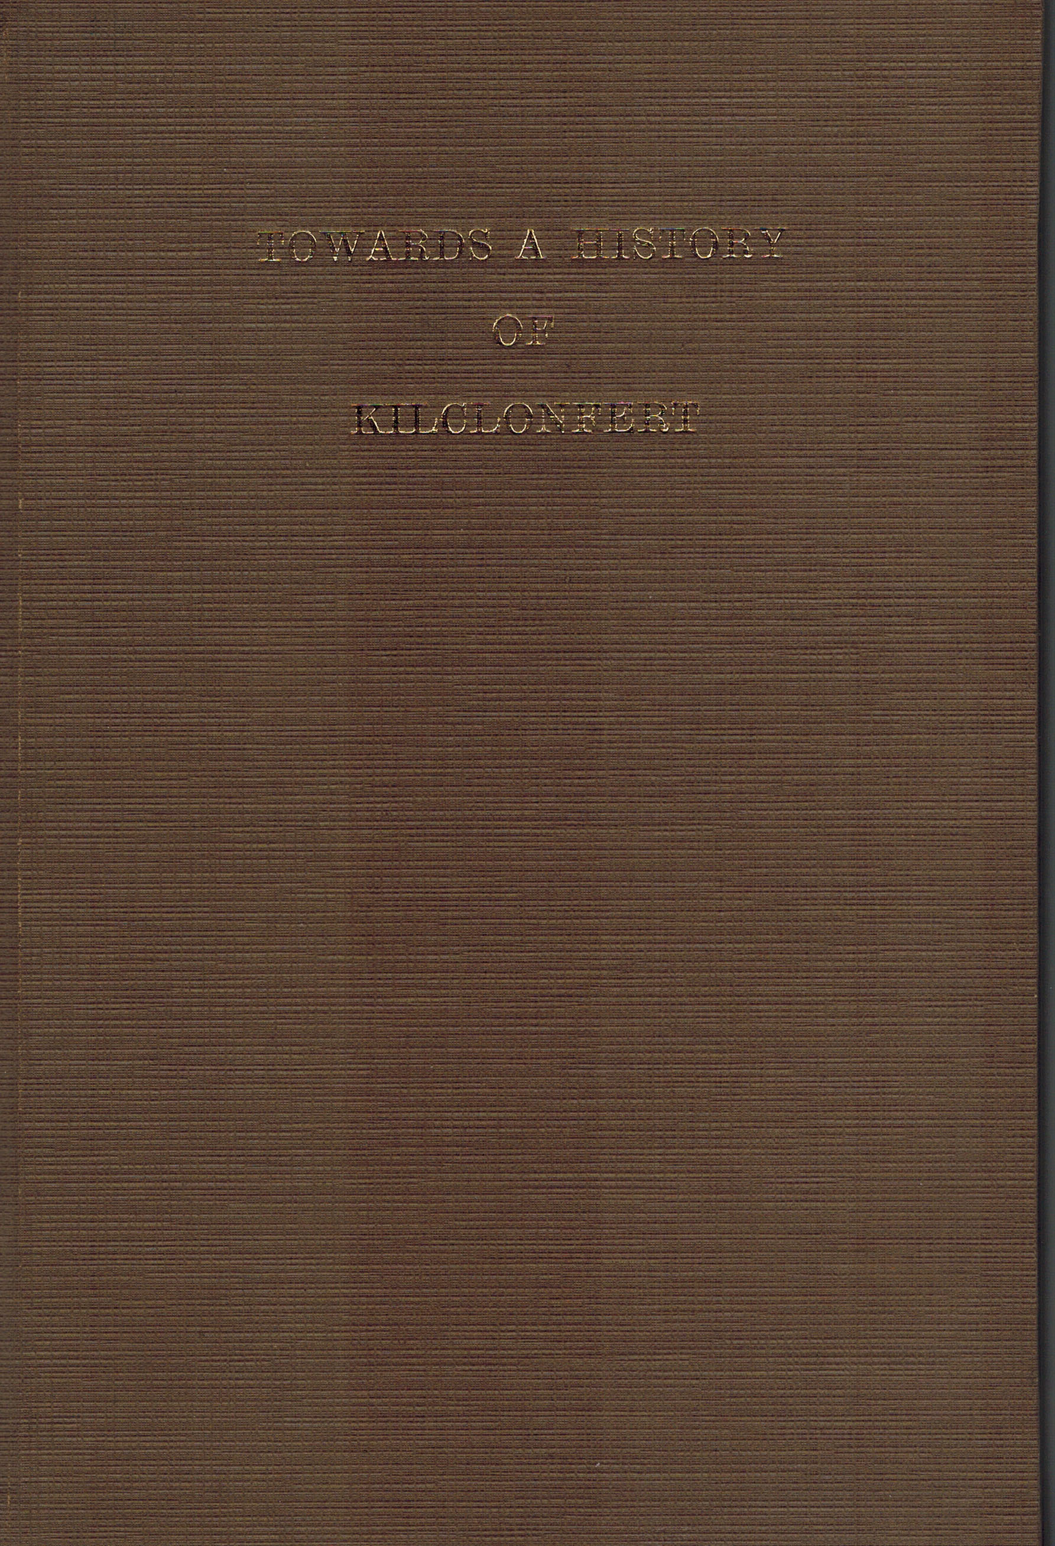 | Towards A History of Kilclonfert (Offaly, 1984), 141pp, HB, €25.00  Edited by Michael Byrne  Towards a history of Kilclonfert  Within the covers of this book is a wonderful and exciting history of Kilclonfert, County Offaly. It also contains an index of the parish registers from the earliest date in the 1790s to the beginning of this century.
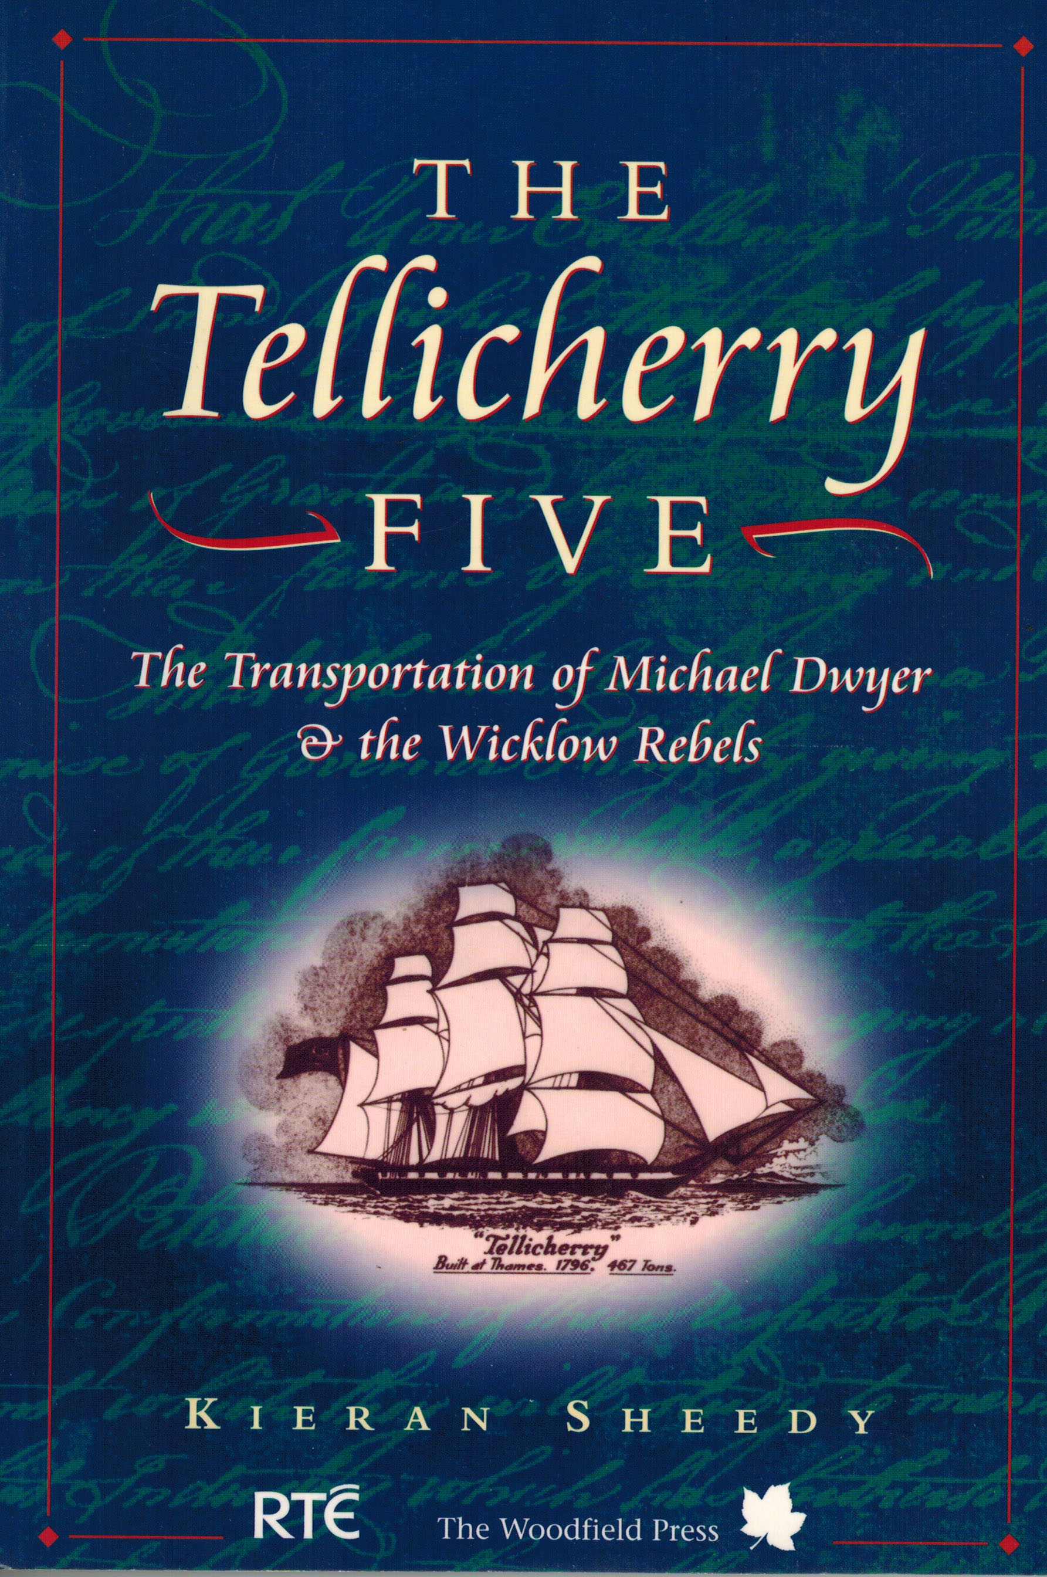 | The Tellicherry Five – The Transportation of Michael Dwyer & the Wicklow Rebels (Dublin, 1997), 183pp, SB, €10.  Kieran Sheedy  The Tellicherry Five is a popular history which reads like fiction; a compelling account of ordinary men and women who survived a period of unimaginable horror and whose ultimate triumph came in the shape of their descendents who helped to shape the destiny of the new land in Australia.
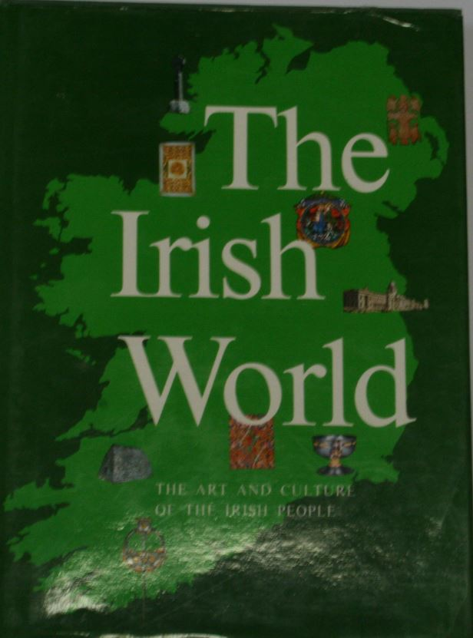 | The Irish World – The Art And Culture of the Irish People ( New York, 1986), 295pp, HB, €20.  Edited by Brian De Breffny  The story of Ireland traces a landscape of peaks and valleys. The first period of her history takes us from the high point of prehistoric Ireland, with its stupendous megalithic monuments, to that of the early Irish Church, which outshone the rest of Europe and created masterpieces of manuscript illumination and metalwork. The Viking invasions, the disturbed Middle Ages, and the brutal struggles of the sixteenth and seventeenth centuries represent a low point. But out of it arose a new and splendid society, the Protestant Ascendancy, imposed from outside but still essentially Irish. The last century and a half have been years of slow advance best with tragedy, but including the strangely lyrical episode of the Celtic Revival in art, poetry, and drama. One whole chapter is devoted to the Irish in America.
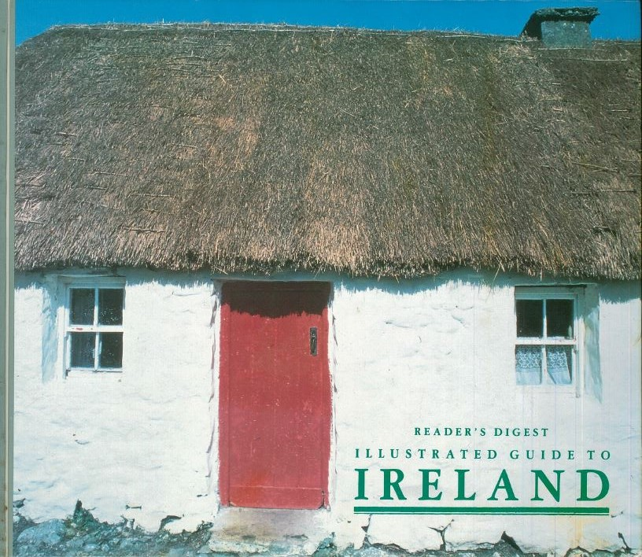 | Readers Digest – Illustrated Guide to Ireland (London, 1992), 352pp, HB €€20  This up-to-the-minute reference has updated detailed maps, hundreds of captivating full-color photographs, and is filled with anecdotes about the history, lifestyle, culture, and folklore of the land and its people as well as totally revised and updated travel facts. This best-selling book is perfect for both armchair and world traveller alike.


ORDER FORM
Esker Press
Bury Quay,
Tullamore,
Co. Offaly
Ireland
Tel.: 00353 5793 21421
Email: info@offalyhistory.com

Buy books on-line at our bookstore and pay with Paypal: www.offalyhistory.com or post as below

Invoice to:  Name: _____________________________  Address: ______________________________  _____________________________________  _____________________________________ | Dispatch to:  Name: __________________________________  Address: ___________________________________  ___________________________________________  ___________________________________________

QTY | ISBN  (if applicable) | Title | Price
 | Author | Title | Price

Subtotal __________

Postage __________

Total ___________

Personal Customers:

Cheque*:
Paypal:

*cheques payable to: Offaly Heritage Centre Ltd.
Postage
Republic of Ireland: €4.95 first copy; €1.50 thereafter.
United Kingdom: Sterling £5; £1.50 thereafter.
Other EU countries: €5.50 first copy; €1.50 thereafter.
N. America : $15; $4 thereafter
Rest of the world: £12: £5 thereafter.

